Order Of Service

Singing: Psalm 33—CW page 79

Reading: Psalm 78:9-20

Opening Hymn: CW 440

Reading: Acts 11:1-18

Request Hymn: CW Supplement 754

Reading: John 20:19-23

Sermon Hymn: CW 391

Sermon Text: Daniel 6:14-18

The Den Of Lions

Prayer

The Apostles’ Creed, TLH page 12

Holy Communion

The Lord's Prayer

The Blessing

Closing Hymn: CW 375

* * * * * * * * * * *

Bible Study: Lambs: Birch Tree
Sheep: Romans 12:9-13
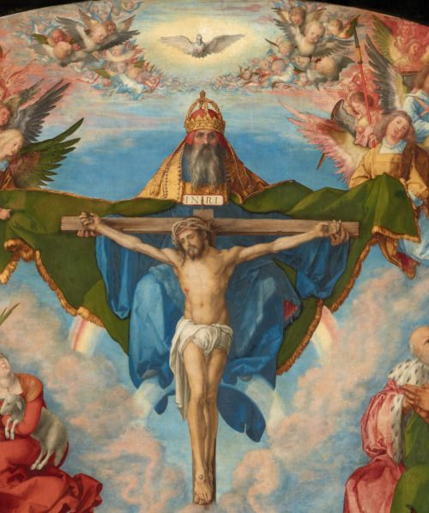

Water
Of
Life

24 June 2018

W A T E R O F L I F E

Independent Christian Church—Conservative Lutheran Doctrine

Worship Service: 9:30 a.m. Bible Study: 10:45 a.m.

Larry Cooper, Pastor E-Mail address:
111 N. Ridge Road lcooper@wateroflife.cc
Coon Valley, WI 54623 Web Site:
Phone: (608) 452-2105 www.wateroflife.cc

* * * * * * * * * * * * * * * * * * * * * * * * * * *

Sermon Text: Daniel 6:14-18

The Den Of Lions

* * * * * * * * * * * * * * * * * * * * * * * * * * *

Daniel 6:14 Then the king, when he heard these words, was sore displeased with himself, and set his heart on Daniel to deliver him: and he laboured till the going down of the sun to deliver him.
:15 Then these men assembled unto the king, and said unto the king, Know, O king, that the law of the Medes and Persians is, That no decree nor statute which the king establisheth may be changed.
:16 Then the king commanded, and they brought Daniel, and cast him into the den of lions. Now the king spake and said unto Daniel, Thy God whom thou servest continually, he will deliver thee.
:17 And a stone was brought, and laid upon the mouth of the den; and the king sealed it with his own signet, and with the signet of his lords; that the purpose might not be changed concerning Daniel.
:18 Then the king went to his palace, and passed the night fasting: neither were instruments of musick brought before him: and his sleep went from him.

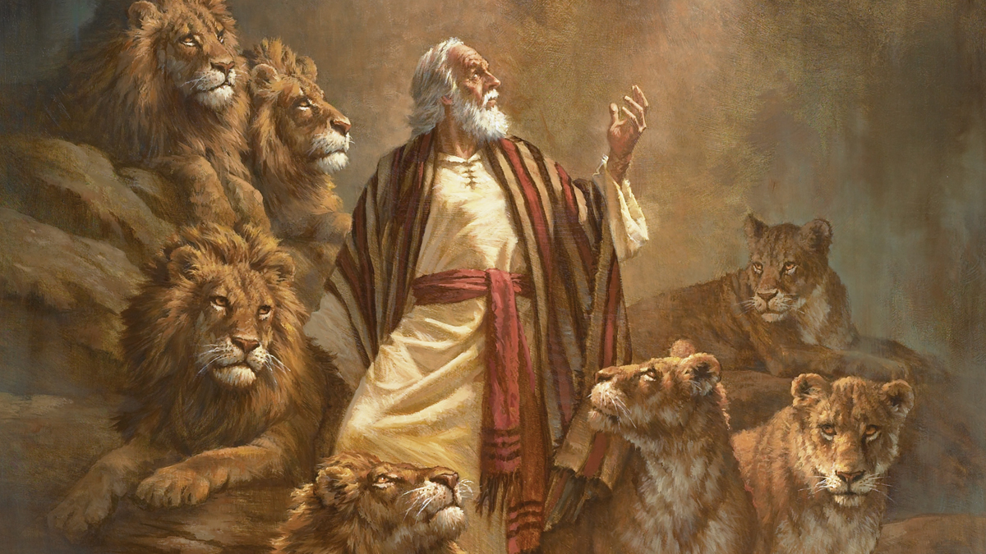

Hebrews 11:32 And what shall I more say? for the time would fail me to tell of Gedeon, and of Barak, and of Samson, and of Jephthae; of David also, and Samuel, and of the prophets:
:33 Who through faith subdued kingdoms, wrought righteousness, obtained promises, stopped the mouths of lions,
:34 Quenched the violence of fire, escaped the edge of the sword, out of weakness were made strong, waxed valiant in fight, turned to flight the armies of the aliens.

